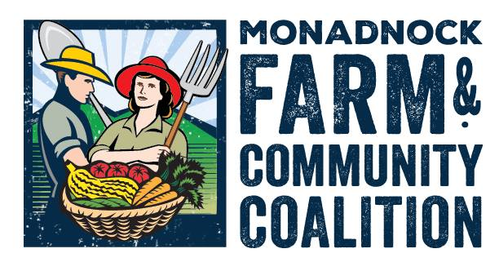
Expand on and create new post-production infrastructure and markets to enhancethe lfoeconomy
INFRASTRUCTURE WORKING GROUP
Expand on and create new post-production infrastructure and markets to enhance or grow the local food economy

--Establish possible distribution centers and increase available storage units and processing facilities, -- Increase the volume of locally produced food sales by improving farmers’ links to market

June 8, 2016 Minutes | June 8, 2016 Agenda
- Present: Matt, Phoebe, Denise, Roe-Ann  - Updates:  - Denise -- Neighbor Made (gluten free kitchen) is opening doors for folks to use their facilities. Cydney Smith and Vivien (Maple Nut Granola). No hot packing equipment  - Genuine Local in Meredith bought NM’s steam kettles & packing equipment  - Coolers are available at NM  - HGC -- (Jake Nonweiler) wrote USDA grant for feasibility study for a Food Hub in NM spot.  - Bagel Works old processing facility is available – has hood, receiving dock, coolers – larger than NM  - TCK -- Sarah needs a gleaning assistant  - Discussion around a mobile food pantry  - Bob Furlone, TCK board member, driven to find a new building.  - Conversation around the need for a centralized food hub, storage and comm kitchen.  - Kingsbury building brought up as a possibility – owes 1.5 million in back taxes.  - RA – Westmoreland Co. Jail is not an option at this point. Commercial kitchen inventory conducted by Senior Ctr.  - Community conversation about SWNH Food Hub:  - MEDEC, Bob Furlone, IWG, MFC, MM, CCCD  - Field trip to Western Mass Food Processing facility planned, Tuesday, June 21. 10am -11:30am  - CCCD awarded HOM pilot scheme to promote farm to school in libraries.  - Farmer Survey  - RA looking for notes from members. Will send out after MFCC board meeting. | - Member updates  - Conversation around Food Hub in SW New Hampshire  - Farmer Infrastructure Survey feedback  NEXT IWG meeting: Wed., July 15, 2016  5pm – 6pm, Hannah Grimes Center, Lower Level

